www.pattyhall.com PATTY HALL www.pattyhall.com
NATIVE DAUGHTER OF THE GOLDEN WEST®

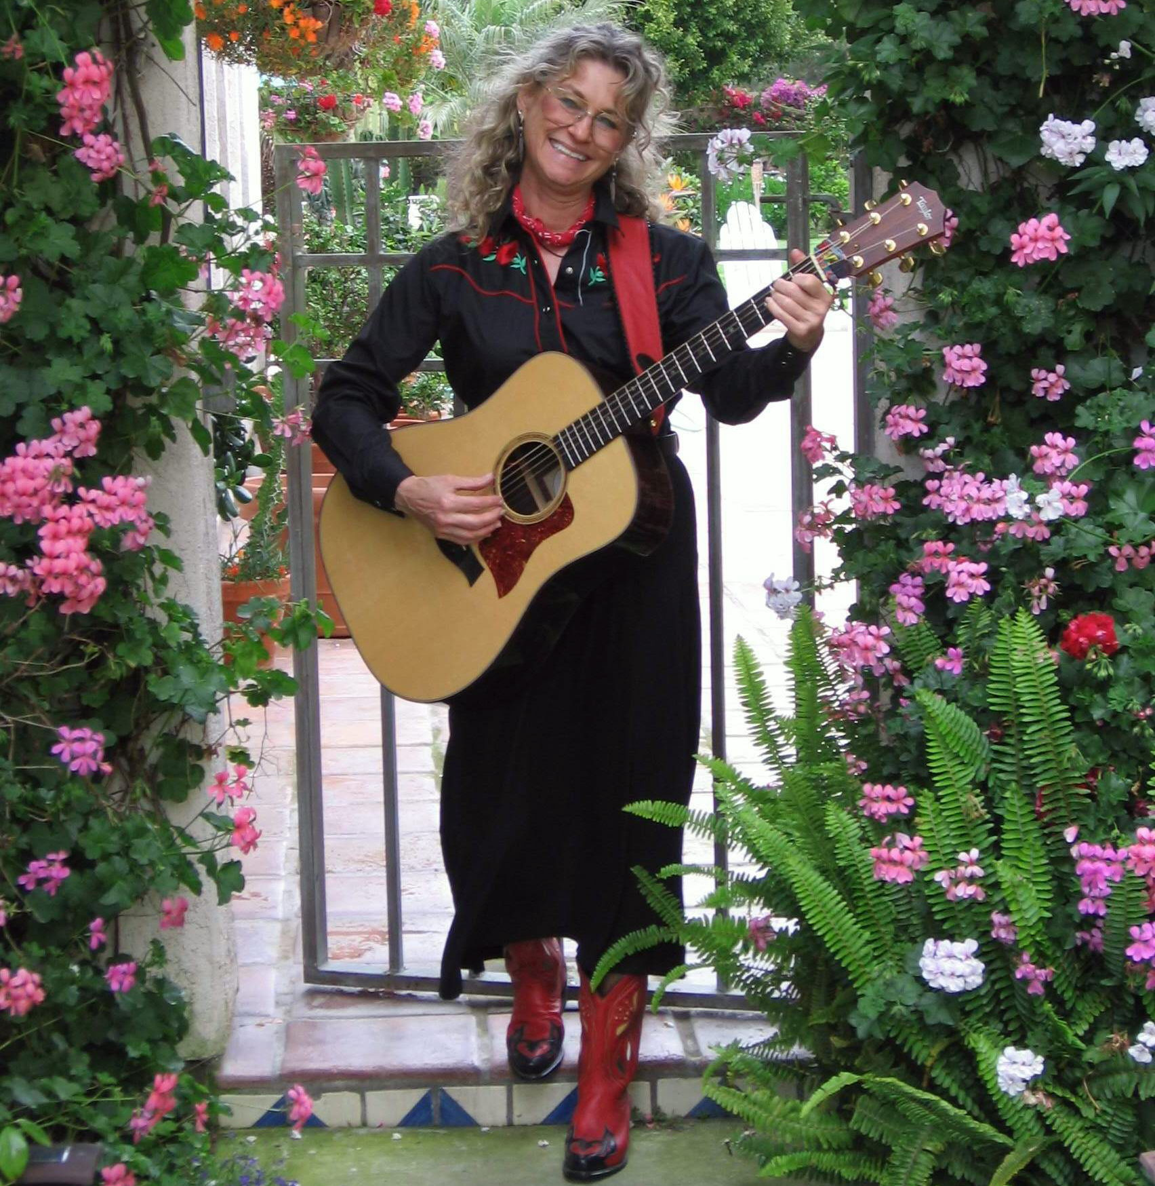

BORDERS BOOKS & MUSIC - VISALIA

13415 South Mooney Blvd. – Visalia – CA

MONDAY - SEPTEMBER 25, 2006
7-9 PM

Come out to BORDERS BOOKS & MUSIC – VISALIA to hear San Diego singer/songwriter/folklorist/author PATTY HALL share her best and newest NATIVE DAUGHTER® music--a unique blend of traditional and original material rendered on guitar, banjo, and a cappella. Her CD, JUST BE GLAD! will be available for sale. For more info call 559-733-2525 or visit:
www.pattyhall.com



